Mini Quiz -1

Name :

Roll No:

EE3003: Power Systems

Dept. of Electrical Engineering, IIT-Madras

1. For the circuit shown below, with the parameters given as: ${\overline{E}}_{aN}=440∠0^{0},$

$$Load_{1}-P_{1}=100 kW, 0.8 power factor lagging$$

$$Load_{2}-P_{2}=50 kW, 0.9 power factor leading$$

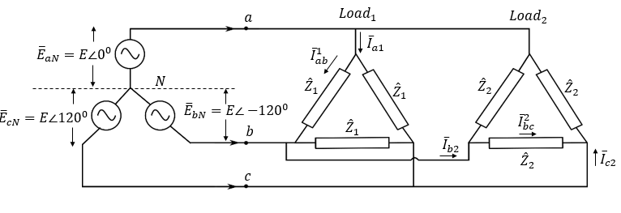

Find the following: (write the answers in rectangular form)

$\left(i\right) {\hat{Z}}_{1}= Ω$, $\left(ii\right) {\hat{Z}}_{2}= Ω$

$\left(iii\right) {\overline{I}}_{ab}^{1}= A$, $\left(iv\right) {\overline{I}}_{bc}^{2}= A$

$\left(v\right) {\overline{I}}_{a1}= A$, $\left(vi\right) {\overline{I}}_{c2} = A$

$\left(vii\right) Q_{1}= kVAr$, $\left(viii\right) Q_{2}= kVAr$

$(ix)$ Real power supplied by source = kW

$(x)$ Apparent power of the source = kVA